COURIER TRACKING APP
@CREATIVITY THINK (9483175986/7019689991)

ABSTRACT:
Courier Tracking App is a web application designed to enhance courier and parcel delivery services. Users can request pickups, track parcel status in real time, receive delivery updates, and view delivery history. Administrators manage shipments, update delivery statuses, oversee drivers, handle support tickets, and generate analytics dashboards. Built using Django and Django Rest Framework for backend functionality and React with Leaflet and Axios for frontend, the system provides a centralized platform for efficient parcel management, real-time tracking, notifications, and comprehensive administrative controls, ensuring transparency and improved delivery operations..

INTRODUCTION OF THE PROJECT:
Managing courier operations manually can lead to delays, miscommunication, and poor visibility of parcel status. Courier Tracking App provides a centralized platform where users can request pickups, track parcels, receive delivery updates, and access historical delivery data. Administrators can manage shipments, update delivery status, assign drivers, handle support tickets, and analyze logistics through dashboards. Using Django and Django Rest Framework for backend services and React with Leaflet and Axios for interactive maps and dashboards, the platform ensures real-time tracking, operational efficiency, and enhanced customer satisfaction in courier services..

PROJECT OBJECTIVES:

• Enable users to request parcel pickups efficiently
• Provide real-time parcel tracking for users
• Send delivery notifications and updates
• Maintain historical delivery records for users
• Allow administrators to manage shipments and driver assignments
• Track support tickets and resolve customer issues
• Generate dashboards and analytics for operational insights

PROBLEM OF THE STATEMENT:
Courier companies and e-commerce delivery services often face difficulties in tracking parcels, managing pickups, and updating delivery statuses manually. Delays and lack of transparency reduce operational efficiency and customer satisfaction. Courier Tracking App addresses these issues by providing a centralized system for pickup requests, parcel tracking, status updates, driver management, support ticket handling, and analytics dashboards. Users gain real-time visibility of shipments, while administrators streamline operations and monitor performance efficiently, reducing errors and improving delivery reliability..

MOTIVATION OF THE PROJECT:
• Provide real-time tracking for users and administrators
• Streamline pickup and delivery management processes
• Ensure timely notifications and delivery updates
• Optimize driver assignments and logistics operations
• Enable analytics for performance tracking and decision-making

BLOCK DAIGRAM OF PROJECT:

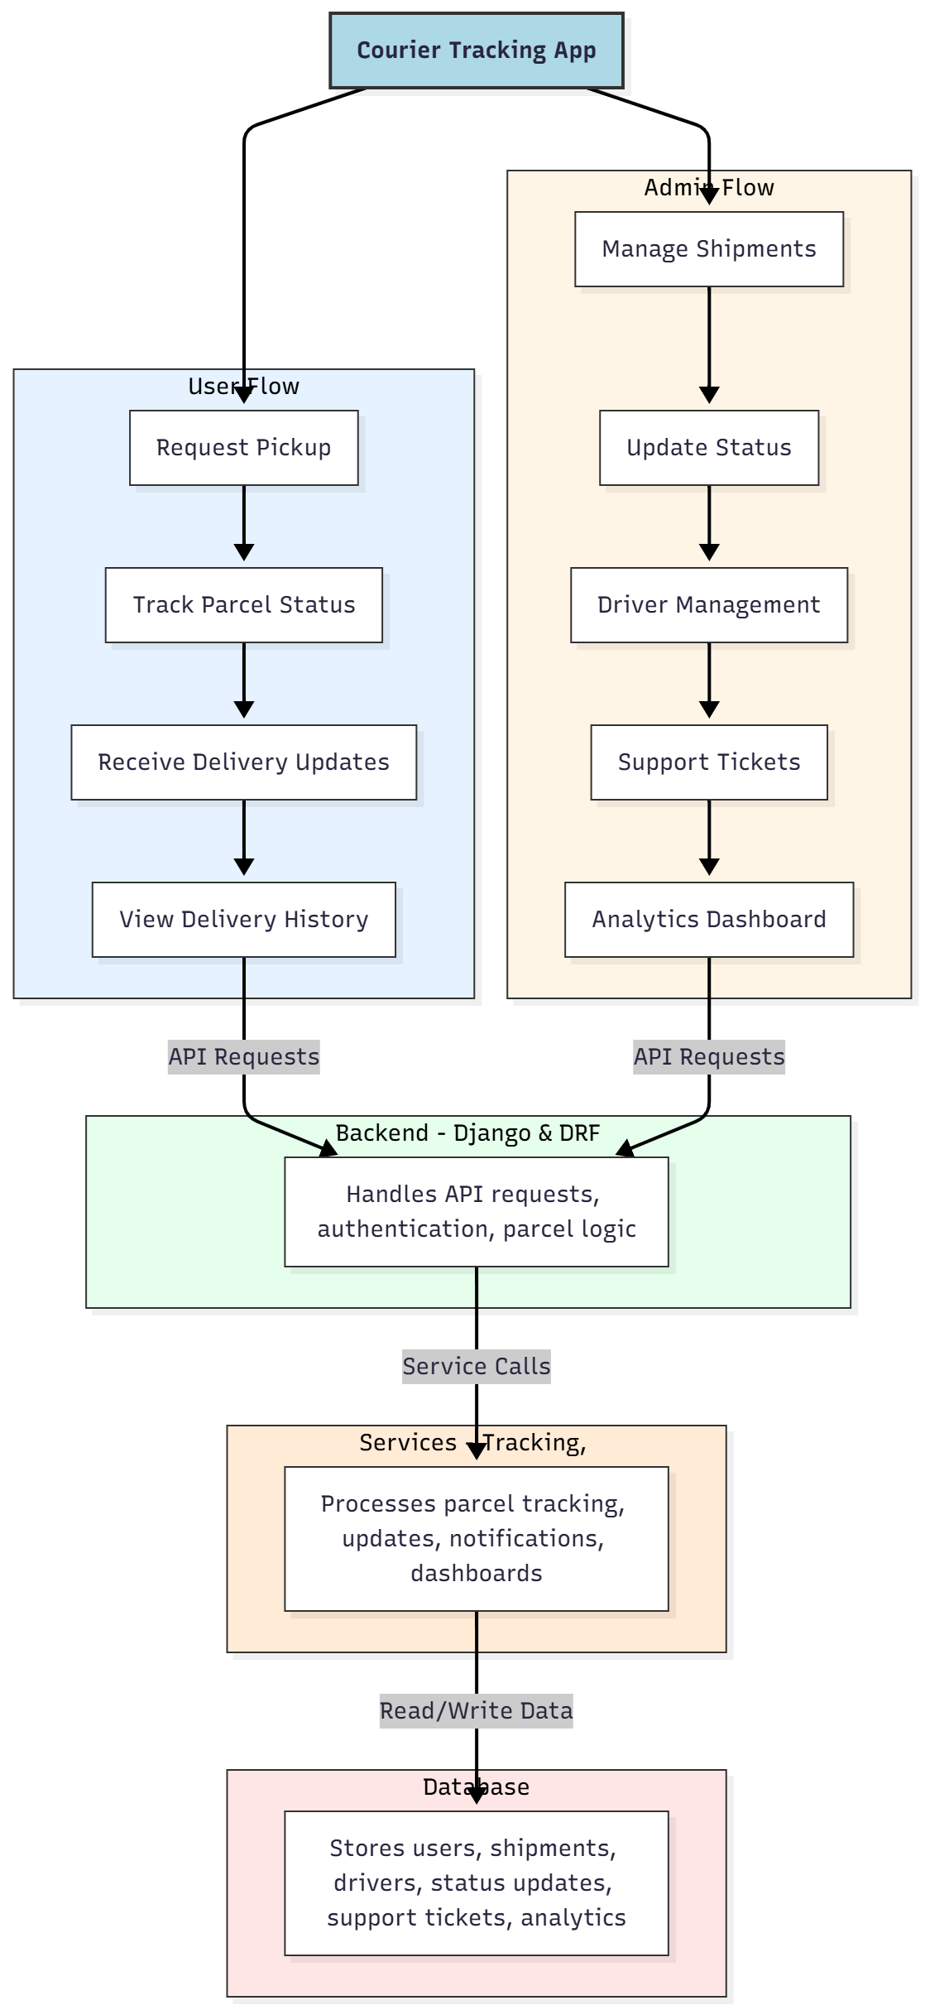

WORKING OF THE PROJECT:
Users request parcel pickups, track their parcels in real time, receive delivery notifications, and view delivery history on dashboards. The backend manages authentication, API requests, and parcel tracking logic. Services handle real-time updates, notifications, and analytics dashboards. Administrators manage shipments, update statuses, assign drivers, handle support tickets, and generate operational analytics. This integrated system ensures efficient logistics operations, accurate parcel tracking, and improved user satisfaction..

SOFTWARE REQUIREMENT:
- Backend:
  - Python 3.x
  - Django
  - Django REST Framework
  - SQLite/PostgreSQL
- Frontend:
  - Node.js and npm
  - React.js
  - Axios
- Development Tools:
  - Visual Studio Code
  - Postman (for testing APIs)
  - Git/GitHub (for version control)
- Server/Deployment (Optional):
  - Gunicorn, Nginx, or Heroku/AWS for hosting

ADVANTAGES OF THE PROJECT:

• Real-time parcel tracking for users and admins
• Streamlined pickup requests and delivery management
• Accurate updates and notifications on parcel status
• Efficient driver and shipment management
• Dashboard analytics for operational insights
• Support ticket tracking for customer service
• Reduces errors and delays in logistics operations
• Enhances customer satisfaction and transparency

APPLICATIONS OF THE PROJECT:
• Courier and logistics companies
• E-commerce delivery tracking
• Last-mile delivery services
• Parcel pickup and dispatch management
• Real-time tracking and notifications
• Analytics dashboards for operations
• Support ticket handling
• Customer dashboards for delivery status

REFERENCES:

- Django REST Framework Documentation — Django Software Foundation. Django Documentation. Available: https://docs.djangoproject.com/
- Django REST Framework. DRF Documentation. Available: https://www.django-rest-framework.org/
- React. React Official Documentation. Available: https://reactjs.org/docs/getting-started.html
- Redux. Redux Documentation. Available: https://redux.js.org/introduction/getting-started
- PostgreSQL Global Development Group. PostgreSQL Documentation. Available: https://www.postgresql.org/docs/
- MySQL. MySQL Reference Manual. Available: https://dev.mysql.com/doc/
- Git. Git Documentation. Available: https://git-scm.com/doc
- Node.js. Node.js Documentation. Available: https://nodejs.org/en/docs/
- Axios. Axios Documentation. Available: https://axios-http.com/docs/intro
- Socket.io Documentation – https://socket.io/docs/

